

HOSPITAL IPOH – ACC PROJECT ACTIVEFM DASHBOARD

Table of Contents

**The ActiveFM Dashboard** **2**

Dashboard Objective 2

Process Flow 2

The Data Manager 3

The RDMA Server (ActiveFM) 3

The End User 3

ActiveFM Management Page 4

Add equipment 4

Add action list 4

Add alarm action 4

ActiveFM Alarm Page 5

Alarm ID 5

Controller 5

Alarm 5

Occurred 5

Estimated time to resolve 5

# The ActiveFM Dashboard

## Dashboard Objective

To provide an interactive dashboard for the alarm management with regards to the Hospital Ipoh, ACC building automation system project.

This dashboard is intended to be used by the facility management personnel onsite to view & act on the alarm that occur from the building automation system.

The dashboard will view the alarm occurred, action to be taken, estimated time to resolve the issue & necessary asset information related to the alarm itself.

## Process Flow

The diagram below shows the flow diagram of alarm notification from the Data Manager to the ActiveFM dashboard;

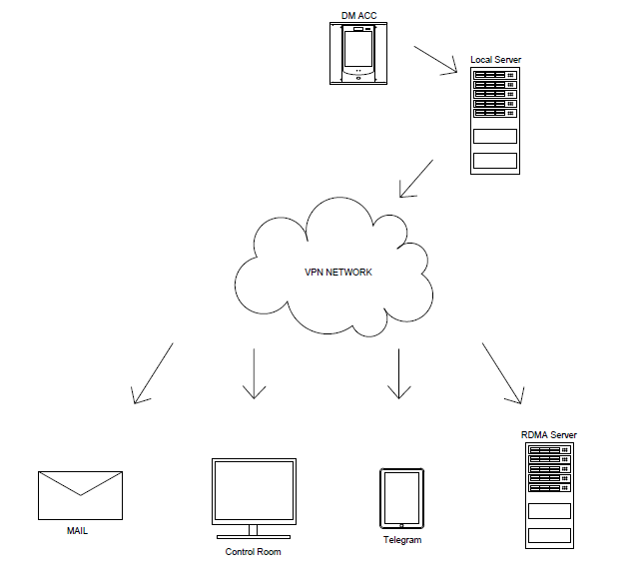

As you can see from the diagram, there are 3 main stages of alarm flow, starting from it source which is the Data Manager & ended with the destination which is the user.

### The Data Manager

An alarm is triggered in the Data Manager which could be a sensor, AHU or Chiller alarm. The alarm is pre-configured to be sent to RDMA server, so as it happens the alarm will be forwarded straight to the server with regards to the network connection between the Data Manager & the server locally.

### The RDMA Server (ActiveFM)

The server will be the main processing part of the alarm. It will tie the alarm with the information that are already preconfigured in the server, as an example the asset number, action to be taken & time to resolve the alarm itself. There’s no interaction needed by the dashboard since the alarm will cleared itself once the issue had been resolved.

### The End User

The end user would be receiving the alarm notification thru email & Telegram Messaging app in their phone. From there, they can take necessary action according to the ActiveFM suggestion or other method to cleared out the alarm.

## ActiveFM Management Page

This page would only be accessible by the admin to setup, edit or delete any alarm actions. The management page overview is as below;

### Add equipment

This page is for admin to add new equipment associated with the devices that are added into the data manager.

Information to added should be as below;

* Asset No.
* Type (Drop-down menu of predefined selections)
* Location (Drop-down menu of predefined selections)
* Picture (if any)
* Additional Information (if any)

This page also allow admin to modify previously added equipment

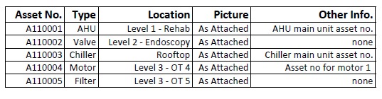

### Add action list

On this page, admin can manually key in every possible action to be taken for each of the alarms that are generated by the devices in data manager. Admin also need to define the estimated time taken to closed/clear the alarm.

This allow the admin to revise the action list later in the future, if there were any improvement or changes.

### Add alarm action

On this page, the controller that available in the Data Manager will be tagged with correspondence asset number. For an example, controller number 1 might cover asset such as AHU, valve & filter.

Also, every possible alarm from the controller will be assigned with action to be taken for each of them based on the action list created earlier by the admin.

## ActiveFM Alarm Page

This is the main page of the dashboard. It will all current alarms in chronological order. From the left hand side there will be the Alarm ID, Controller the alarm generated from, Alarm occur timestamp, Action to be taken & Estimated time taken to resolve the alarm.

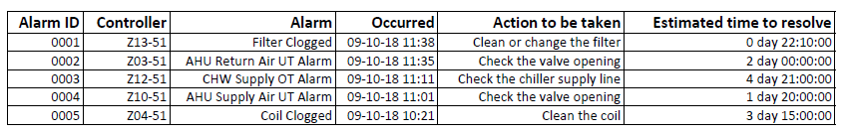

### 

### Alarm ID

A running number of every alarms receive by the ActiveFM dashboard. This ID could be used to view the historical alarm later for future references.

### Controller

List of controllers where the alarm is generated from. Can be clicked to view additional info related to the controller (asset, picture, location, etc.).

### Alarm

The alarm that receive by the server from the respective controllers.

### Occurred

The timestamp that the alarm occurs, this item can be clicked to view the other previous timestamp that the identical alarm occurs for the controller.

### Estimated time to resolve

Shown a fixed estimated time taken to resolve the alarm. This is defined by admin in the management page prior.